Click on the VgerSelect icon on the computer desktop (looks like binoculars):

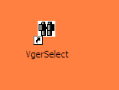

After VgerSelect opens either use an existing Group Definition or click on the button to create a new one.

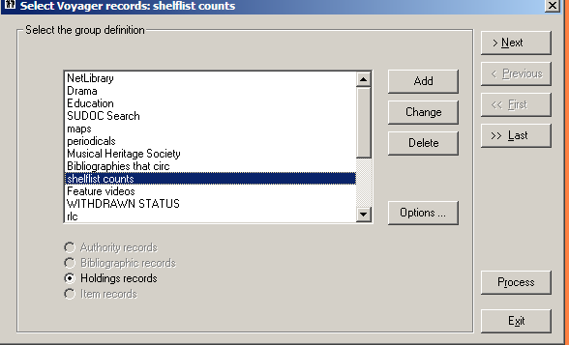

Type in a name for the new Group. “AV Counts” and click 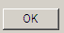

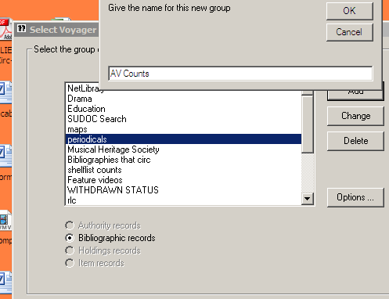

At the next screen click on the radio button for Holdings Records (not bibliographic records) and click the  button to continue.

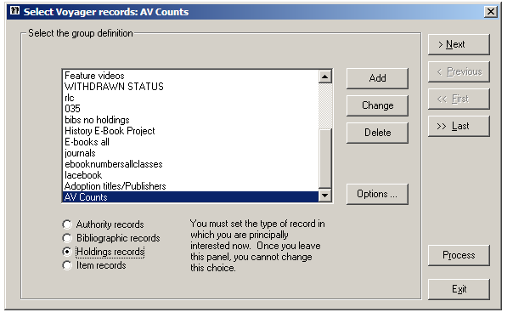

The next screen should be set as follows, and click the button to continue.

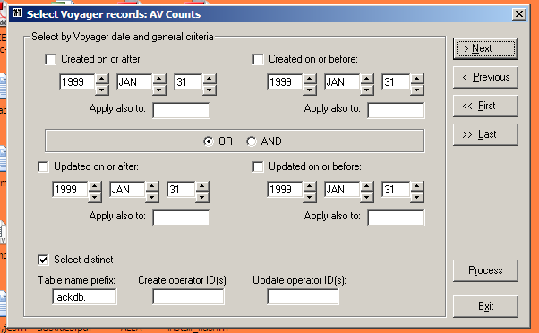

At the next screen enter the call number ranges for the AV holdings to be counted 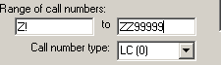 Note: ZZ9999 inclusive range

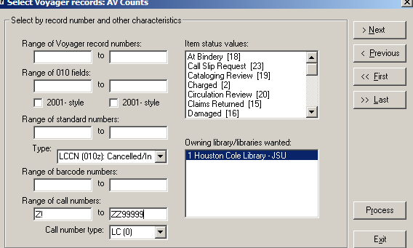

Ignore the next screen and click the button to continue

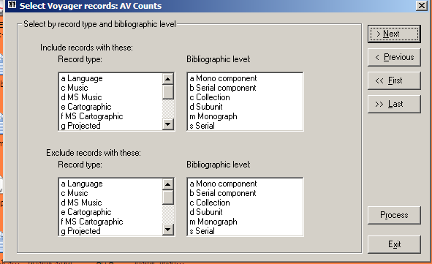

The next screen is where the locations to be counted should be added. Click on the  button to retrieve a list of possible locations.
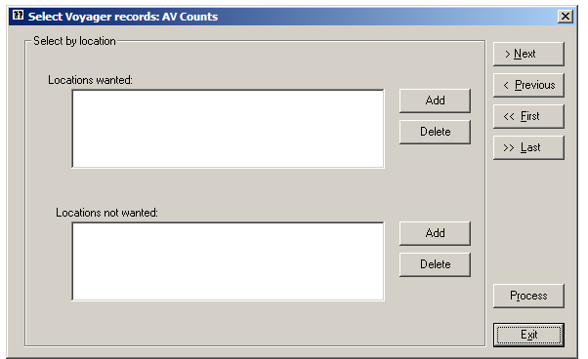

Highlight the desired locations from the list that pops up and click Click the button to continue.

The locations for AV Holdings are:

AV Center 16mm films
AV Center cassettes
AV Center Software
AV Center filmstrips
AV Center kits
AV Center records
AV Center slides
AV Sound Compact Disks
AV Center transparencies
AV Center video cassettes
AV Center videodisks (OLD

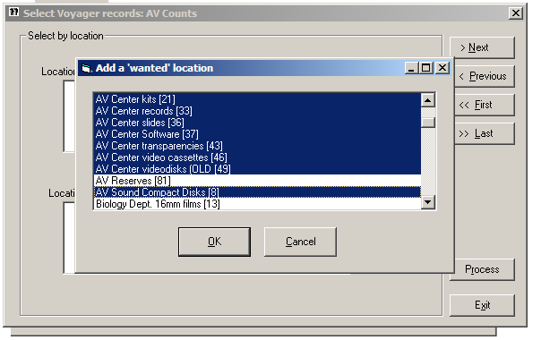
Ignore the next screen and click the button to continue.

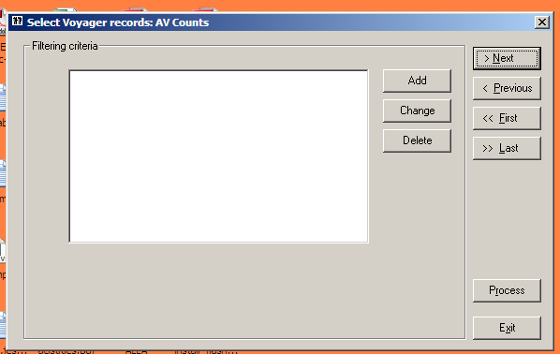

Ignore the next screen and click the button to continue.

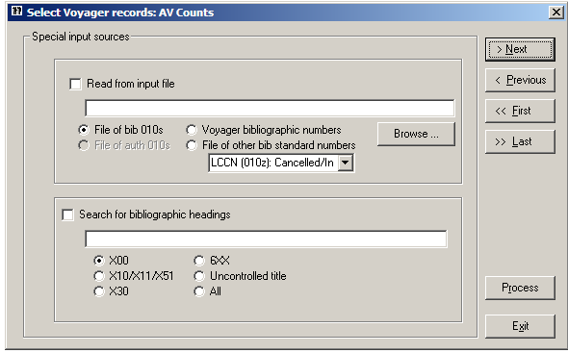.
The next screen is where the format for the output files (what will become a detailed list of the counts) can be customized. Select the checkboxes for Ignore suppressed holdings records and Consider only MFHDS from chosen locations. At this same screen select the checkbox for Selected elements. This will enable the 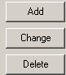 options. Click on the button.

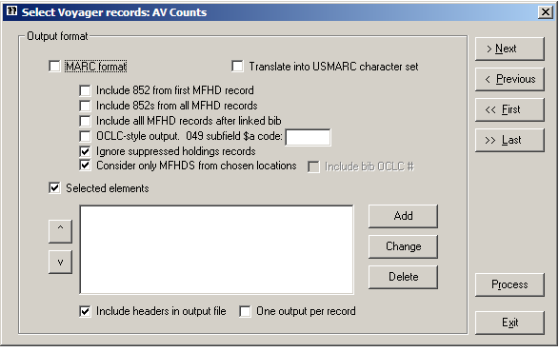

At the next screen label the column Call Number: 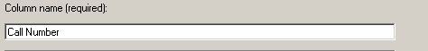
Click the appropriate radio button for the call number from the holdings record and mark that subfield codes be removed.

and

Click

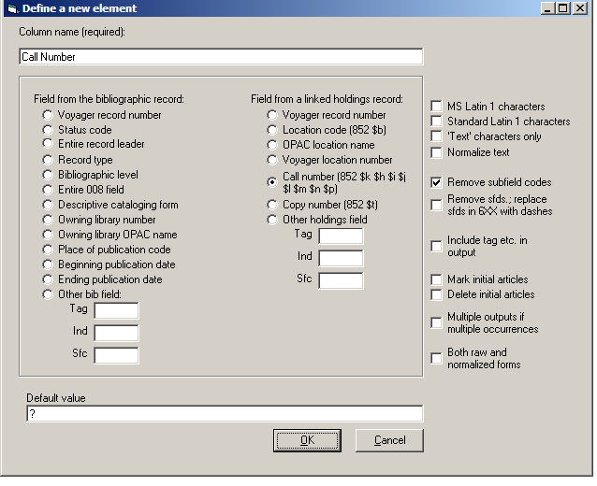

The resulting screen should look as follows:

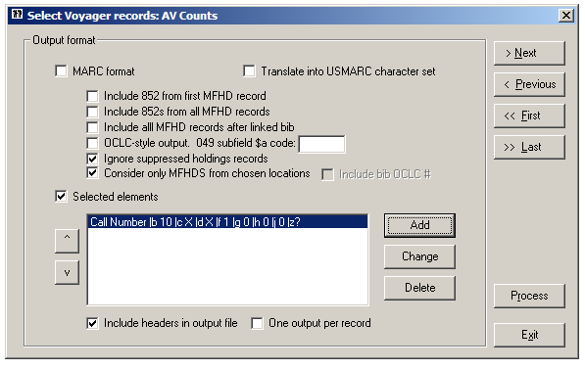

To add an additional element to the report, the Location, again, click on the button. At the next screen label the column Location 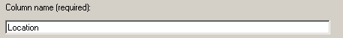

and click in the radio button for Location code 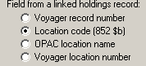
and click .

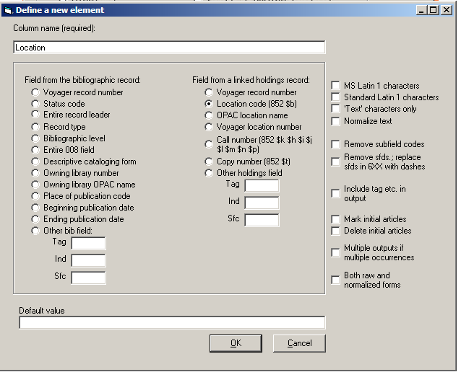

The resulting screen should now have two Selected Elements for the

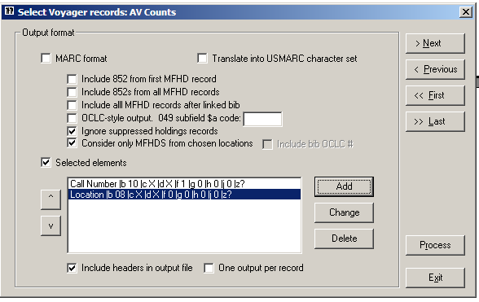

To add an additional element to the report, the Location, again, click on the button. At the next screen label the column Title

Select Other bib field: and add 245 to the tag field

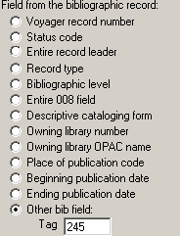 and Click

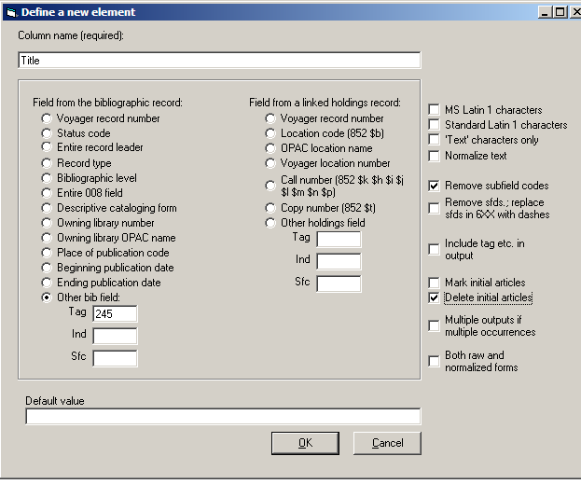
The resulting screen should now have three elements defined for the report:

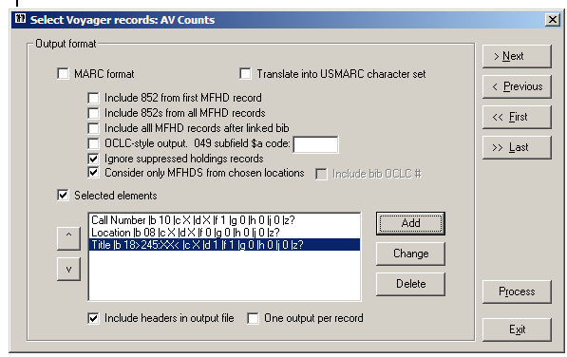

Click on the check box for “Include headers in output file” and click the button.

At the next screen define the name of the file and where the file is to be saved.
It is suggested that to aid in locating the files that they be placed on the Desktop. The path for this directory is C:\Documents and Settings\Library User\Desktop

The Unique File Name radio button is selected and the file named AV Holdings
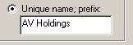 You may opt to use the Generic name.

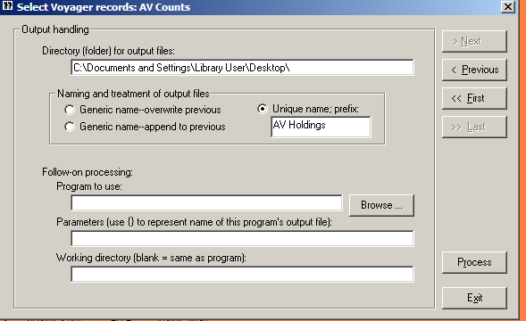

To run the report, click on the 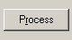 button.

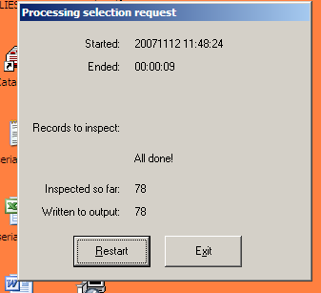

Two reports will be generated and will appear on the computer desktop as text files. 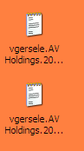

The file with the report.txt suffix is a summary of the actions taken:

***********************************************
* *
* Select Voyager bibliographic records *
* *
***********************************************

20071109 12:54:00 Job began
20071109 12:54:06 Job ended
00:00:06 Elapsed time for job

20071109 12:54:00 Search (SQL step) began
20071109 12:54:00 Search (SQL step) ended
00:00:00 Elapsed time for search step

20071109 12:54:00 Examination of records began
20071109 12:54:06 Examination of records ended
00:00:06 Elapsed time for examination
0.0769230769 Average time (seconds) to examine each record
13.0 Records examined per second
780.0 Records examined per minute

Initial SQL statement:
SELECT DISTINCT T1.BIB_ID FROM jackdb.BIB_MASTER T1,
jackdb.MFHD_MASTER T2, jackdb.BIB_MFHD T3 WHERE
(T2.NORMALIZED_CALL_NO BETWEEN 'Z 1' AND 'Z 9999' AND
T2.CALL_NO_TYPE = '0') AND T2.LOCATION_ID IN (14, 38, 55, 17,
21, 33, 36, 37, 43, 46, 49, 8) AND T1.BIB_ID = T3.BIB_ID AND
T3.MFHD_ID = T2.MFHD_ID

0 records to be read
78 records actually read

78 accepted for inclusion in output file

78 lines written to output file: C:\Documents and Settings\Library User\Desktop\vgersele.AV Holdings.20071109.125400.data.txt

The second report is the raw data generated by the search. The suffix for the file will be data.txt. Which will open with WordPad.

Call Number Location Title
Z675 .U5C6 no.6 Using library resources for a research paper (Filmstrip)
Z675.S3 U8x Use your library: for better grades and fun, too! [Filmstrip].
Z678.2 .T43 Technical implications of the NCLIS report. [Sound recording]
Z675 .S3S3 School library media centers. [Sound recording]
Z689 .B6 Book marketing and selection [sound recording] : a publishing/library forum.
Z716.2 .B85 Building bridges to the future. [Filmstrip]
Z675.S3 T5 Focus on three: Casis reading guidance program [Filmstrip]
Z675.S3 T5 Focus on three : Allisonville evaluates (Filmstrip)
Z675.S3 T5 Focus on three : Mount Royal, the inner city (Filmstrip)
Z 675.S3 L5 Living school libraries [filmstrip] : a progress report.
Z711.2 .S9x Surviving : an introduction to the use of the college library. [Filmstrip].
Z668 .E38 Educating librarians and users for a new model of library service. Sound recording
Z733 .N48 New direction for libraries. [Filmstrip]
Z 710 .L56 Library: what's in it for you? [Filmstrip]
Z675.S3 T5 Three for tomorrow. [Filmstrip]
Z665 .A515 96th annual ALA conference. Sound recording
Z682 .C76 Co-operating with the librarian. Filmstrip
Z665 .M35x Making the library a learning center. Filmstrip
Z 56 .H34x 1974 Intermediate shorthand : Century 21 dictation/transcription / Berle Haggblade, Mary Ellen Oliverio and Edward L. Christensen ; shorthand plates written by Stanford D. DeMille.
Z56 .C47x 1974 Introductory shorthand kit : Century 21 / Edward L. Christensen and R. Dermont Bell ; shorthand plates written by Grace A. Bowman and Stanford D. DeMille.
Z665 .A515 1978 [Proceedings of the annual conference] sound recording
Z696.U4 L5 Library of Congress classification. [Filmstrip]
Z682 .E46 1984 Employee selection and minimum qualifications for librarians / edited by Keith M. Cottam.
Z1003 .H68x 1984 How to read a book videorecording
Z716.3 .B66 1986 Booktalking [videorecording] / with Joni Bodart ; assisted by Larry Rakow and Jacqueline Brown Woody.
Z682.25 .W74 1985 Writing library job descriptions.
Z696.D7 C37x 1985 Card catalog, Dewey decimal classification [videorecording] / a Words, Inc. production.
Z671 .L5x Library video magazine [videorecording]
From here, the WordPad document can be copied into Word and converted to a table. How?

Open the data.txt file click on Edit > Select All > Copy

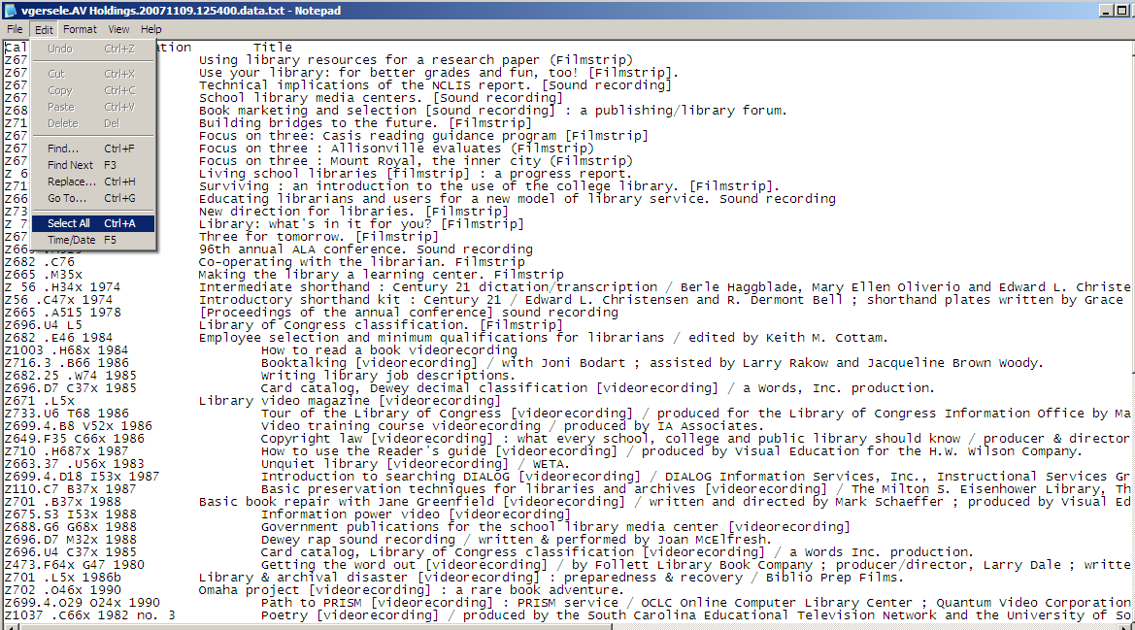

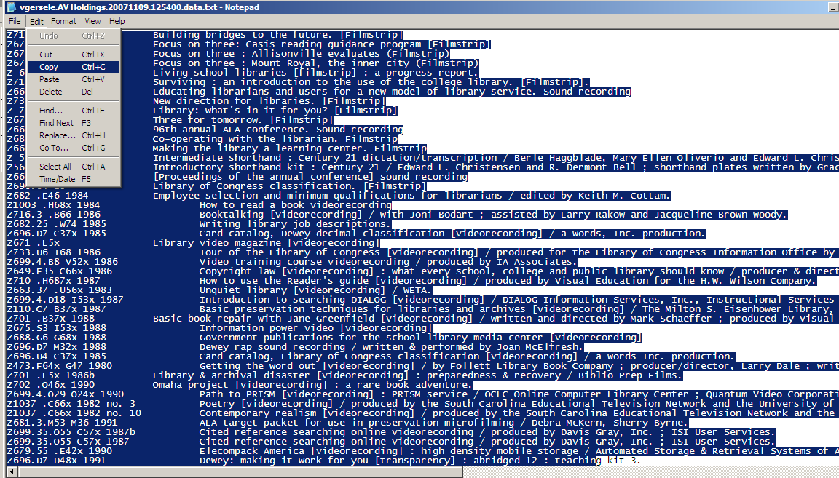
Open a blank document in Microsoft Word and paste the data into Word. The data will be unformatted at this time. See sample below:

Call Number Location Title
Z675 .U5C6 no.6 Using library resources for a research paper (Filmstrip)
Z675.S3 U8x Use your library: for better grades and fun, too! [Filmstrip].
Z678.2 .T43 Technical implications of the NCLIS report. [Sound recording]
Z675 .S3S3 School library media centers. [Sound recording]
Z689 .B6 Book marketing and selection [sound recording] : a publishing/library forum.
Z716.2 .B85 Building bridges to the future. [Filmstrip]
Z675.S3 T5 Focus on three: Casis reading guidance program [Filmstrip]
Z675.S3 T5 Focus on three : Allisonville evaluates (Filmstrip)
Z675.S3 T5 Focus on three : Mount Royal, the inner city (Filmstrip)
Z 675.S3 L5 Living school libraries [filmstrip] : a progress report.
Z711.2 .S9x Surviving : an introduction to the use of the college library. [Filmstrip].
Z668 .E38 Educating librarians and users for a new model of library service. Sound recording
Z733 .N48 New direction for libraries. [Filmstrip]
Z 710 .L56 Library: what's in it for you? [Filmstrip]
Z675.S3 T5 Three for tomorrow. [Filmstrip]
Z665 .A515 96th annual ALA conference. Sound recording
Z682 .C76 Co-operating with the librarian. Filmstrip
Z665 .M35x Making the library a learning center. Filmstrip
Z 56 .H34x 1974 Intermediate shorthand : Century 21 dictation/transcription / Berle Haggblade, Mary Ellen Oliverio and Edward L. Christensen ; shorthand plates written by Stanford D. DeMille.
Z56 .C47x 1974 Introductory shorthand kit : Century 21 / Edward L. Christensen and R. Dermont Bell ; shorthand plates written by Grace A. Bowman and Stanford D. DeMille.
Z665 .A515 1978 [Proceedings of the annual conference] sound recording
Z696.U4 L5 Library of Congress classification. [Filmstrip]
Z682 .E46 1984 Employee selection and minimum qualifications for librarians / edited by Keith M. Cottam.
Z1003 .H68x 1984 How to read a book videorecording
Z716.3 .B66 1986 Booktalking [videorecording] / with Joni Bodart ; assisted by Larry Rakow and Jacqueline Brown Woody.
Z682.25 .W74 1985 Writing library job descriptions.
Z696.D7 C37x 1985 Card catalog, Dewey decimal classification [videorecording] / a Words, Inc. production.
]

To convert the data into a table with columns and headings click on Edit > Select all. After the data is highlighted click on Table > Convert > Text to table:

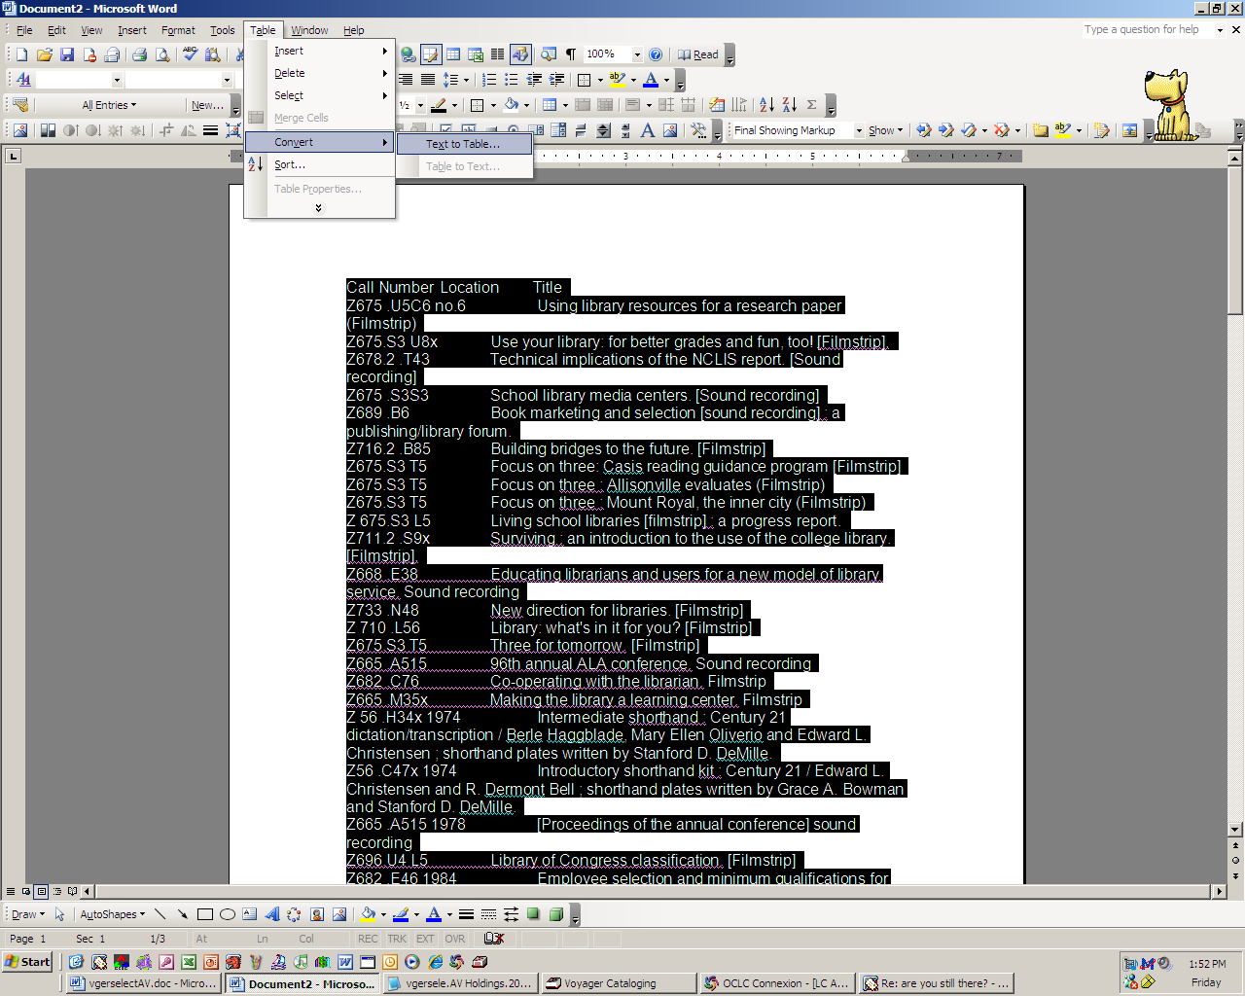

A jump box will appear, please click on the radio button for Tabs under “Separate text as” This will separate the three elements into columns in the table. See table below.

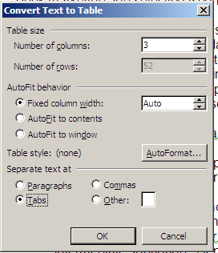

Call Number | Location | Title
Z675 .U5C6 no.6 |  | Using library resources for a research paper (Filmstrip)
Z675.S3 U8x |  | Use your library: for better grades and fun, too! [Filmstrip].
Z678.2 .T43 |  | Technical implications of the NCLIS report. [Sound recording]
Z675 .S3S3 |  | School library media centers. [Sound recording]
Z689 .B6 |  | Book marketing and selection [sound recording] : a publishing/library forum.
Z716.2 .B85 |  | Building bridges to the future. [Filmstrip]
Z675.S3 T5 |  | Focus on three: Casis reading guidance program [Filmstrip]
Z675.S3 T5 |  | Focus on three : Allisonville evaluates (Filmstrip)
Hint: to get the top row to appear as a heading on each page:

Place the cursor on the top row. Click Table > Table properties. Click on the tab for ROW and click in the check box



